Understanding your school’s survey report

A: Results from parents and guardians with children in school
 | Your school’s name and roll number
 | Results from parents and guardians with children in school:  This section shows the percentage of parents/guardians that responded to survey, who indicated a preference for a:  - Co-education or single-sex school  - Multi-denominational or denominational school  - Education through Irish or through English
 | School Response Rate (bottom left):  This tells you how many parents/guardians responded to the survey. For example, if your school has children from 100 households, and 40 responded, this is 40% response rate.
 | Overall School Margin of Error (bottom right):  We cannot say for certain what all parents and guardians of children in school prefer, if not all parents/guardians responded to the survey. Instead, we make an estimate based on the responses we received. The margin of error shows how much the result might be higher or lower, if all parents/guardians did the survey.
How to read the numbers
When you read the results, the percentages shown in green and gold, show the preferences of the parents/guardians who took part in the survey.
The red line shows the margin of error. This gives a range around the survey result, showing how much the result might be higher or lower if all parents/guardians of children in your school had responded. For example: if the whole red line is above 50%, this means it is likely that more than half of all parents/guardians prefer that option, even allowing for the margin of error.
If many parents/guardians of children in school responded to the survey, the result is more reliable and leads to a smaller margin of error. If fewer parents/guardians respond, the result is less certain and leads to a larger margin of error. The margin of error only relates to the parents/guardians with children currently in school.

Example of how the percentages are calculated
- A school has children from parents/guardians in 100 households.
- 40 parents/guardians responded to the survey – this is a 40% response rate.
- 30 parents/guardians said they would prefer a co-educational school and 10 would prefer a single-sex school.
- The percentage preference for co-educational school is: 30 out of 40 = 75%
- The percentage preference for single-sex school is: 10 out of 40 = 25%
- The margin of error is plus or minus 12%
- This means the true figure for co-education could be as low as 63% and as high as 87%.
- This shows that if the remaining households had responded, the preference would likely not fall below 63%.
A

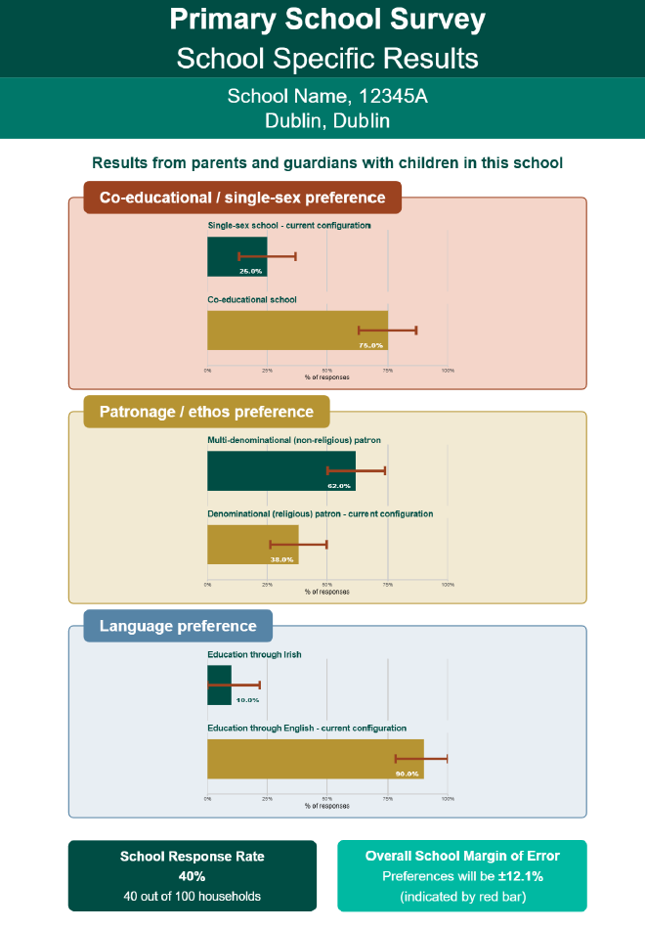
Margin of error

B: Results from parents and guardians who indicated that they intend to enrol their children in this school in the future

This page shows the preferences of parents/guardians, who indicated that they intend to enrol their children in this school in the future.
The number of parents/guardians that responded to the survey is shown at the top of the page.
Results from parents and guardians who indicated that they intend to enrol their children in this school.
This section shows the percentage of parents/guardians that responded to survey, who indicated a preference for a:
- Co-education or single-sex school
- Multi-denominational or denominational school
- Education through Irish or through English

How to read the numbers
When you read the results, the percentages shown in green and gold, show the preferences of the parents/guardians who took part in the survey.
There is no margin of error shown on this page because we do not know the total number of parents or guardians who may choose this school in the future. We would need this total number to be able to calculate a margin of error.
These results can give a useful indication of possible future demand only, rather than a statistically robust measure of overall preference.

Notes
Where no results are shown for future pupils
In some school results, there may be no information on this section. This can happen because no parents/guardians responded to the survey or only a small number of parents/guardians responded to the survey. Small numbers are not shown in order to keep the results reliable.
Staff and Board of Management results
Results from staff and Board members are not included in your school results. This is to protect confidentiality, especially in smaller schools. These results will be used later if your school wishes to explore a change in configuration.
B
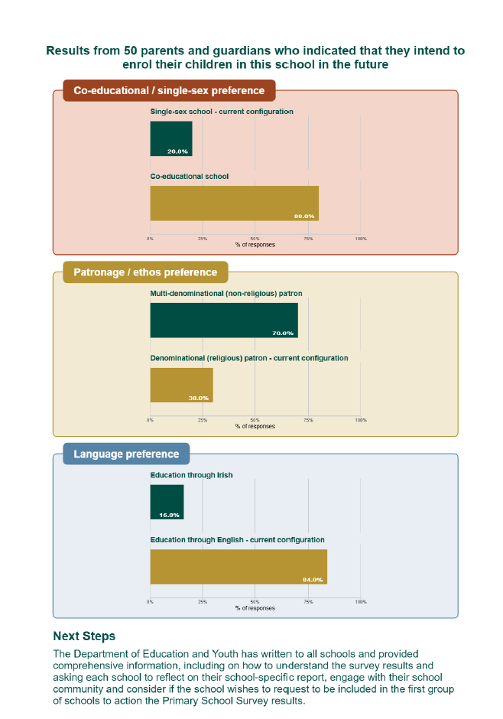

Clear preference for no change (examples)
These examples show when results clearly support staying the same:
- Single-sex school:
58% want to remain single-sex
Margin of error: 5% → range is 53%–63%
→ Still above 50%, so a clear preference for no change
- Denominational school:
70% want to remain denominational
Margin of error: 15% → range is 55%–85%
→ Clear preference for no change
- English-medium school:
75% want to stay English-medium
Margin of error: 10% → range is 65%–85%
→ Clear preference for no change

Clear preference for change (examples)
These examples show when results clearly support change:
- Single-sex school:
80% want to become co-educational
Margin of error: 3% → range is 77%–83%
→ Clear preference for change
- Denominational school:
60% want to become multi-denominational
Margin of error: 5% → range is 55%–65%
→ Clear preference for change
- English-medium school:
75% want to become Irish-medium
Margin of error: 5% → range is 70%–80%
→ Clear preference for change

Final point
If results are unclear, the Board of Management should:
- Look carefully at all the information
- Consider feedback from their parents/guardians, staff and local community
- Take time before deciding on next steps
This process is about understanding what your school community wants and responding in a thoughtful and informed way.

